8th EUROPEAN INTER BANK BOWLING CHALLENGE

MILAN (ITALY)

EASTER 2001

APRIL 14-15/2001

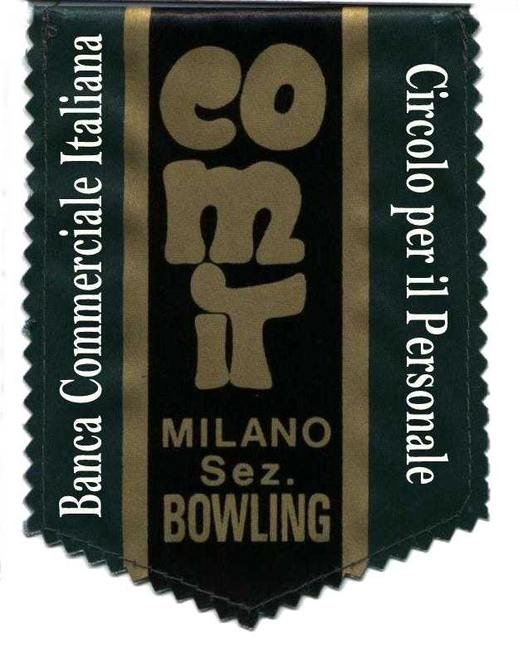

HOSTED BY

CIRCOLO PER IL PERSONALE
B.C.I.
MILANO

8th EUROPEAN INTER BANK BOWLING CHALLENGE
Milan, Italy
Easter 2001 – APRIL 14/15.2001

The European Inter Bank Bowling Challenge was established in 1987, at the iniziative of Mr. Michel Adamson, Sport Association of Banque de France - Chameliers.
Circolo per il Personale della Banca Commerciale Italiana - Milano is hosting the 8th edition at "Bowling dei Fiori - via Renzo e Lucia nr. 4 - Milan".

The Challenge is open to 48 teams composed by 4 players (plus 2 substitutes max.) representing the same Banking Institution of the same Country.
The captain of each team must have a declaration stating that all the team players are employees of the concerned Bank.
Each participant to the Challenge must be a member of his/hers National Bowling Association/Federation.
Lady participants will have an additional 10 pins per game.
The entry fee is fixed Itl. 350.000.= per team.

Closing date for entries is January 31, 2001. Entries to be returned as soon as possible to Circolo per il Personale della Banca Commerciale Italiana, via Amedei 8, 20123 Milano, fax +39 02-88503032 - eMail: (mrepetti@bci.it – dsanfelici@bci.it – pstefanoni@bci.it - dpedroni@bci.it ).
Each team must wear a shirt of the same color, stating the name of the Banking Institutions.
Is suggested that the trousers/skirt have the same colour for each team.

Competition rules
Saturday: each team will play two running series of 3 games each.
Sunday: teams will be divided into two sections, based on the position.
Challange Section:
The top teams (24 teams max) will be divided into two equal groups (1/3/5…and 2/4/6…) and will play 3 games to be added to the 50% of the pins of the previous series of Saturday. The top 4 teams of each group will form two groups composed by 4 teams (the 1° and the 3° of one group with the 2° and the 4° of the other group) and will play a robin-round format, starting from 0 pins, with a bonus of 60 pins for a win and 30 pins for a tie. The first teams of each group will play a final game in order to obtain the winner team. The remaining second teams will play for the 3° and 4° position.
Plate section:
the remaining teams classified (24 teams max) will play with the same rules of the Challenge section.
In case of drawn series, will be considered the lower difference between the best team game and the worse team game; in case of further drawn result will be considered the team which comes from the far Country. In case of a tie at final game, will be considered the team which has accumulated more pins (excluding bonus) over all games.
The Challenge is approved by Federazione Italiana Sport Bowling and current F.I.Q.-E.Z. rules govern this tournament.

Awards
The winner team of the Challenge Section will receive the European Interbank Champion Cup; all the players of the first 4 teams classified will receive a single premium. Also the first 4 teams of the Plate Section will be awarded a prize. The Plate winner will receive also the AIB perpetual trophy.
Special prizes will be available for highest team game, the highest single game M/F, the highest series of 3 games per team, the highest series per player M/F, other prizes are at disposal of the Organisation.
An individual may receive one individual prize only.

TEAM ENTRY FORM

BANK NAME

TEAM NAME

COUNTRY

Player Surname | Player First Name | Playing Order
 |  | 1
 |  | 2
 |  | 3
 |  | 4
 |  | 1° Substitute
 |  | 2° Substitute

BANQUET

Sunday night, April 15.2001 there will be a banquet organised for all the players and their supporters. This banquet will be held at "Hotel Sporting" - Via Sporting Mirasole, Opera (Milano).
The cost is Itl. 75.000.= per person.

Bank Name | Number of Partecipants

Total payment of entries and banquet to be effected from January 01/2001 up to January 31/2001, All teams entered will be informed later about payment instructions .

HOTEL

Hotel Sporting Mirasole - Via Sporting Mirasole 56 - Opera (Milano).
Telefono: +39-02 5768031 - Fax: +39-02 57601461 - e-Mail keyhotels@pn.itnet.it
Cost per room per night for two people including breakfast: Itl. 150.000.=; cost per room per night for three people including breakfast: Itl. 195.000.=
Please, send a copy of this filled page both Hotel and Organisation Challenge by Fax or by e-Mail.

BANK NAME

Number of players:
Number of supporters:

Arrival date: Hour:
Departure date: Hour:
Transport:

Occupants Name | Thursday night | Friday night | Saturday night | Sunday night | Monday night | Double / Triple Rooms

An advance payment of two nights Itl. 300.000.= for double and Itl. 390.000 for triple room to be sent within March 01/2001 in favour of: Key Hotels s.r.l. – c/o Banca Popolare di Milano, Bernareggio Branch no. 538 - account no. 10411 – ABI 5584 – cab. 32500.
Balance will be settled on departure.

