



16th EUROPEAN INTER BANK TEN PIN
BOWLING CHALLENGE

VIENNA – AUSTRIA
EASTER 2017 APRIL 15 – 16 /2017

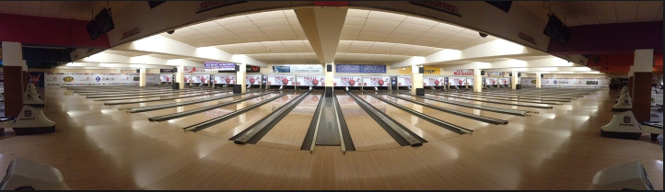



HOSTED BY
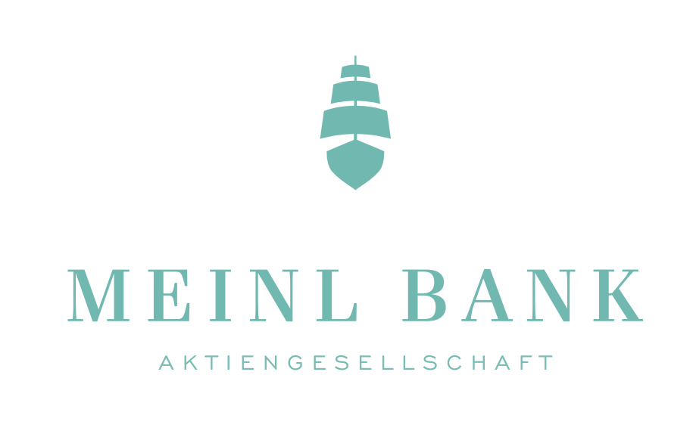

MEINL BANK AG

16th EUROPEAN INTER BANK TEN PIN BOWLING CHALLENGE
VIENNA, AUSTRIA
EASTER 2017 – April 15th to 16th 2017

Meinl Bank welcomes all participants of the 16th European Inter Bank Tenpin Bowling Challenge, held on the Easter weekend – Saturday to Sunday 15th-16th of April 2017.

Two years have passed from the last and perfect championship in Bruxelles and we have been looking forward to meeting you again.
A special welcome to those teams participating for the first time in this competition.

The European Inter Bank Tenpin Bowling Challenge was first held in 1987, at the initiative of Sport Association of Banque de France – CHAMALIERES. It has been held at various venues around Europe every second year since then – (see European Inter Bank Tenpin Bowling at http://www.bowlingaziendale.it/ )

The entry fee is € 300 per team.

We would appreciate your returning the entry forms as soon as possible and no later than 23rd of January 2017.
Since only 60 teams can be accepted, we will apply “first come-first served allocation”.

Accommodation:

All accommodation are to be reserved at the Senator Hotel Vienna ****.
We have negotiated very attractive prices for you!

Rate per Room/night including breakfast, WLAN & city taxes :
One person 78€
Two persons 100€
Three persons 122€

We have negotiated the same price for people who wish to stay longer in our city.
There are the same room prices in the period from 10/04 till 19/04.

To get this rate, you must use the “Reservation form EURO 2017” attached to this mail. This hotel has a perfect location near the center of the city, in the “Hernalser Hauptstrasse”.
The folder of the hotel is also attached to this mail.

Sunday night the 16th a banquet and the Victory Ceremony for all players and supporters will be held at the Plus Bowling Center.

The cost is € 70 / person

BOWLING CENTRE

The 16th European Inter Bank Tenpin Bowling Challenge will be staged at the Plus Bowling:

http://www.plusbowling.at

PAYMENT

Total payment for entry fees and banquet tickets must be paid at the same-time as your entry.
Payments are to be made by SWIFT (no cheques) with all charges paid in favour of

Account Name: Weiss Günter – Banken EM
Account no: AT721924000400443958
SWIFTBIC: MEINATWW

Please add Ref/Message: "Euro Interbank (your Bank/Team Name)".

Remember, for the hotel reservation you must use the “Reservation form EURO 2017”.

You will find in attachment the following documents :

- euro challenge 2017 entry form.doc
- euro challenge 2017 playing rules.doc
- Reservation form EURO 2017.xlsx
- Presentation.pdf

We have attached an entry form and a copy of the rules governing the competition.

The final plans for schedule and bus transfers will be sent after January 23rd since we have to wait for how many teams will participate.

If you need more information concerning this competition please contact:

Thomas Gross or Daniel Hahn
gross@meinlbank.com hahn@meinlbank.com

tel : (00 43) 1 531 88 120 (00 43) 1 531 88 560

