



16th EUROPEAN INTER BANK TEN PIN
BOWLING CHALLENGE

VIENNA – AUSTRIA
EASTER 2017 APRIL 15 – 16 / 2017

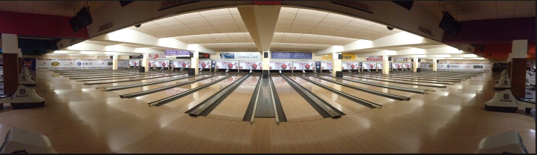



HOSTED BY

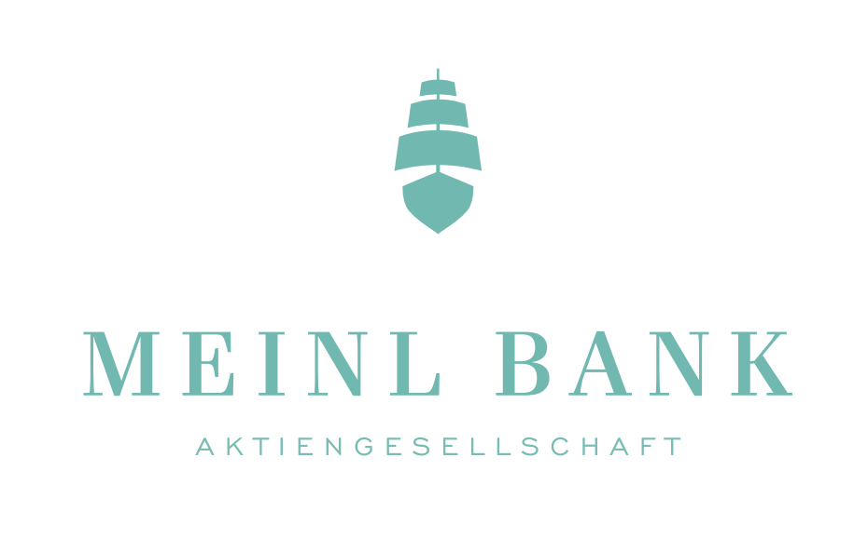

MEINL BANK AG

PLAYING RULES

- The tournament will be run under the control and jurisdiction of the ”Plus Bowling” which committee will be responsible for the tournament Management.

- The tournament will be run under the general playing rules of the FIQ together with the following special rules, which will govern the tournament.

- Each team member must be a member of her/his own National Bowling Association/Federation.

- Each team member must wear a bowling shirt of the same colour, with the Bank and Country name on the back or on the shoulder. Trousers/skirts should be of the same colour for each team member.

ELIGIBILITY

- The tournament is open to Bank teams representing the same Banking Institution in the same European Country. Each team may have a maximum of five eligible players of which four will play each game.
- No person may play in the tournament except those originally entered or such replacements as authorised by the team captain and accepted by the Tournament Management prior to the start of play.
- Each team captain must be in possession of a written confirmation that all the team players are either:
  - employees of the respective Bank;
  - a retired staff member in receipt of a pension from the respective Bank or,
  - is a qualifying team member under rule 8 (below) specifying the relationship that player claims for eligibility.

- A team may have one player who is not an active or retired employee of the Bank. However, this player must be related in first degree (husband/wife/father/mother/child) to one of the other players on the team.
- Ladies will have an additional 10 pins per game throughout the competition.

COMPETITION FORMAT

- Preliminaries - Saturday: each team will play two series of three games.

- Position Games - Sunday: teams will be divided into two sections based on their finishing position on Saturday to compete in either the Challenge or Plate Sections. The top 20 teams from Saturday will play in the Challenge and the remaining teams will play in the Plate. 50% of Saturday’s scores will be brought forward to this series.

Challenge Section - the teams will be divided into two equal groups and will play 3 games - Group A: 1/3/5 etc. and Group B: 2/4/6/ etc.

Plate Section - the remaining teams will be divided into two equal groups and will play 3 games - Group C: 17/19/21 etc. and Group D: 18/20/22 etc

- Round Robin – Sunday: The top four teams in each of the ‘Position Games’ groups will form two groups of four and play a round robin format within the group. Each team plays one game against each opponent with a bonus of 80 pins for a win and 40 pins for a tie. The scores from previous rounds will be brought forward to the round robin.

Challenge Section:-
Group 1: 1st and 3rd teams from Group A and 2nd and 4th from Group B
Group 2: 2nd and 4th teams from Group A and 1st and 3rd teams from Group B

Plate Section:
Group 3: 1st and 3rd teams from Group C and 2nd and 4th teams from Group D
Group 4: 2nd and 4th teams from Group C and 1st and 3rd teams from Group D

- Final

Challenge Section:
The 1st placed teams in Groups 1 and 2 will play a final game in order to determine the European Inter Bank Ten Pin Bowling Champion. The 2nd placed teams in each group will play a final game to determine the 3rd and 4th position in the Challenge section.

Plate Section:
The 1st placed team in Groups 3 and 4 will play a final game in order to determine the Plate winner. The 2nd placed team in each group will play a final game to determine the 3rd and 4th position in the Plate section.

TEAM POSITIONS AND SCORES
- Preliminaries (Saturday) - Team positions will be determined by total pinfall accumulated, including any ladies handicap, but only 50% of this is carried forward into Sunday’s Position Games.

Position Games (Sunday) - team positions in each group will be determined by the 50% brought forward from Saturday plus the total pinfall, including any ladies handicap, achieved in this series.

Round Robin (Sunday) - team positions in each group will be determined by the scores (100%) brought forward from the Position Games plus the total pinfall, including ladies handicap, and bonus pins achieved in the round robin series.

Tie breaker - In the event of a tie for any position the highest last game of the tied teams will determine the team position except in the final where the 9th/10th frame roll off will resolve a tie.

DISPUTES
- A provisional ball shall be rolled in the case of a dispute which cannot be settled on the spot. Any protests must be made verbally to the Tournament Management at the time and confirmed in writing within 2 hours. The Tournament Committee’s decision shall be final.

ENTRY FEES
- The entry fee of € 300 is payable by Swift transfer at the time the entry is submitted - see payment details below. Entry fee is non-returnable after squad details have been accepted.

CLOSING DATE

- All entry forms must be received by the 23rd January, 2017. Entry form should be emailed to :

hahn@meinlbank.com

AWARDS

- Team; The Champions will be awarded the European Challenge Trophy. There will be individual awards for each player competing in the final.

The Plate winners will receive the “AIB Perpetual Plate Trophy”. There will be individual awards for each player competing in the final.

In addition there will be Team High Game and Team High Series awards based on the 9 games in the Preliminaries and Position Games. A team may receive only one of these team awards.

Individuals: There will be individual awards – both male and female - for High Game, High Average (must have played 50% of the games) and High Series based on the 9 games in the Preliminaries and Position Games. An individual may receive one individual prize only.

