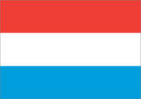 |  |  |  |  |  | 

PROGRAMME FOR THE
16th EUROPEAN INTER BANK
TENPIN
BOWLING CHALLENGE
VIENNA – AUSTRIA
EASTER 2017 APRIL 15 – 16 /2017

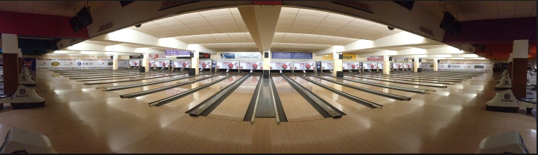



HOSTED BY

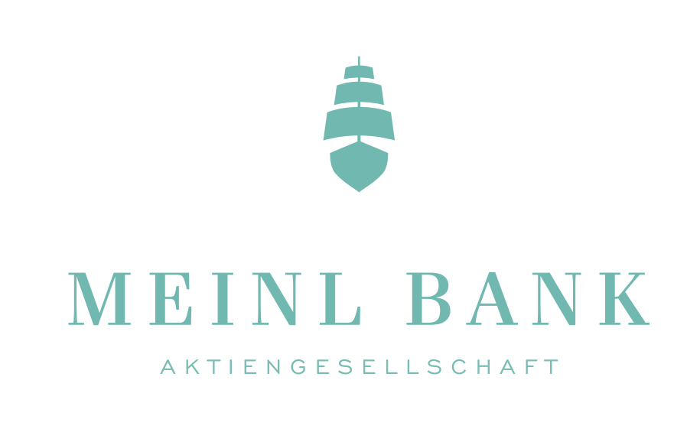

MEINL BANK AG

Welcome everybody!

Soon the 16th Edition of the European Inter-Banking Bowling Challenge will be held in Vienna, Austria.

Program and schedule of the tournament:

FRIDAY APRIL 14th 2017:

14⁰⁰ - 19³⁰ - Plus Bowling

- Training possible for the teams. Ask the bowling centre for reservation
  - http://www.plusbowling.at
  - Beheimgasse 5-7, 1170 Vienna, Austria

- Possibility to take the gifts & Team check-in

SATURDAY APRIL 15th 2017:

19 teams - Series 1

08³⁰ Registration/Captains briefing – Plus Bowling
09⁰⁰ Series 1 - three games – 1 to 3

Lane maintenance & Lunch (available at the Bowling Centre)

19 teams - Series 2

13⁰⁰ Series 2 - three games – 4 to 6

16th EUROPEAN TEN PIN BOWLING INTER BANK CHALLENGE
Vienna, AUSTRIA - Easter 2017

PROGRAMME

SUNDAY 16th April, 2017

Position Series

Plate - Round Two -Teams position 11-19 from Saturday

09⁰⁰ games 7 to 9 – Plus Bowling

Challenge - Round Two - Teams position 1-10 from Saturday

09⁰⁰ games 7 to 9 – Plus Bowling

Lane maintenance (Lunch available in Bowling Centre)

Round Robin Series

Challenge and Plate

13³⁰ eight teams will be divided into 2 groups of 4 (1/4/5/8 & 2/3/6/7)
13³⁰ eight teams will be divided into 2 groups of 4 (11/14/15/18 & 12/13/16/17)

Finals

17⁰⁰ 1st placed team in each Round Robin section play one game final for the European Challenge Champion and for European Plate.

17⁰⁰ 2nd placed team in each Round Robin section play a one game final for 3rd and 4th places in the Challenge or Plate.

20⁰⁰ Presentation Banquet – Plus Bowling

Dinner and price ceremony

The lunch and price ceremony will be held at “Plus Bowling”
  - http://www.plusbowling.at
  - Beheimgasse 5-7, 1170 Vienna, Austria

The timing of the event:

20⁰⁰ Aperitif’s

20³⁰ Dinner and price ceremony

22³⁰ Dancing

COMPETITION FORMAT

SATURDAY 15TH APRIL - Preliminaries

Each team plays two series of three games

SUNDAY 16TH APRIL: Position Games, Round Robin and Final

50% of Saturday’s scores will be brought forward to Sunday.
The 19 Teams will be divided into Challenge (10) and Plate (9) sections.
Each section will play a three game ‘Position’ series followed by a ‘Round Robin’ series leading to a one-game final.

Position Series
Plate – 09⁰⁰ Teams finishing from 11th to 19th on Saturday’s will play a position series of three games with 50% of Saturday’s scores brought forward.
Challenge – 09⁰⁰ Teams finishing from 1st to 10th place on Saturday will play a position series of three games with 50% of Saturday’s scores brought forward.
Teams positioned 9th and 10th from Challenge aswell as 9th from Plate series will be eliminated after Position Series.
Round Robin – 13³⁰

The top eight teams of Challenge will form two groups of four to play a round robin series.
The top eight teams of Plate will also form two groups of four to play a round robin series.
Each team plays one game against each opponent with a bonus of 80 pins for a win and 40 pins for a tie.

Challenge:-

Group 1: Place 1/4/5/8
Group 2: Place 2/3/6/7

Plate:
Group 3: Place 11/14/15/18
Group 4: Place 12/13/16/17

Final 17⁰⁰

Challenge:

The 1st placed teams in Groups 1 and 2 Round Robin will play a final game in order to determine the European Champion. The 2nd placed teams in each group will play a final game to determine the 3rd and 4th position.

Plate:

The 1st placed team in Groups 3 and 4 Round Robin will play a final game in order to determine the Plate winner. The 2nd placed team in each group will play a final game to determine the 3rd and 4th position in the Plate section.

TEAM POSITIONS AND SCORES

Note: Ladies will have an additional 10 pins per game throughout the competition.

Preliminaries (Saturday) - Team positions will be determined by total pinfall accumulated, including any ladies handicap, but only 50% of this is carried forward into Sunday’s Position Series. Top 10 go to Challenge; rest to Plate.

Position Series (Sunday) - team positions in each group will be determined by the 50% brought forward from Saturday plus the total pinfall, including any ladies handicap, achieved in this series.

Round Robin (Sunday) - team positions in each group will be determined by the total pinfall, including ladies handicap, and bonus pins achieved.

Tie breaker - In the event of a tie for any position the highest last game of the tied teams will determine the team position except in the final where the 9th/10th frame roll off will resolve a tie.

DISPUTES

A provisional ball shall be rolled in case of a dispute which cannot be settled on the spot. Any protests must be made verbally to the Tournament Management at the time and confirmed in writing within 2 hours. The Tournament Committee’s decision shall be final.

AWARDS

Team; The Champions will be awarded the European Challenge Trophy. There will be individual awards for each player competing in the final.

The Plate winners will receive the AIB Perpetual Plate Trophy. There will be individual awards for each player competing in the final.

In addition there will be Team High Game and Team High Series awards based on the 9 games in the Preliminaries and Position Games. A team may receive only one of these team awards.

Individuals: There will be individual awards – both male and female - for High Game, High Average (must have played 50% of the games) and High Series based on the 9 games in the Preliminaries and Position Games. An individual may receive one individual prize only.

BOWLING ATTIRE
Each team member must wear a bowling shirt that has the same colour; the Bank and Country names on the back.

LANE DRESSING PATTERN
Lanes are Synthetic Active FA-010 and the oil pattern will be the Plus Bowling House Shot.

BALL PARK
This will be available at the bowl from Friday until Sunday

TOURNAMENT MANAGEMENT
The tournament will be run under the control and jurisdiction of the Austrian Bowling Federation in coordination with “Plus Bowling”; this committee will be responsible for the tournament Management.

ELIGIBILITY
See Tournament Rules for full details.

