



15th EUROPEAN INTER BANK TEN PIN
BOWLING CHALLENGE



BRUXELLES – BELGIUM
EASTER 2015 APRIL 04 – 05 /2015

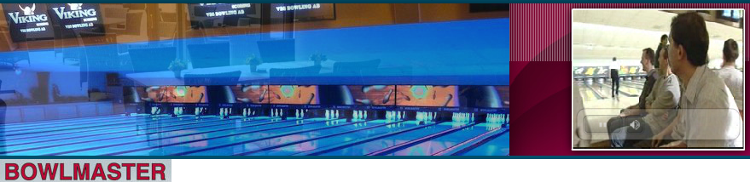

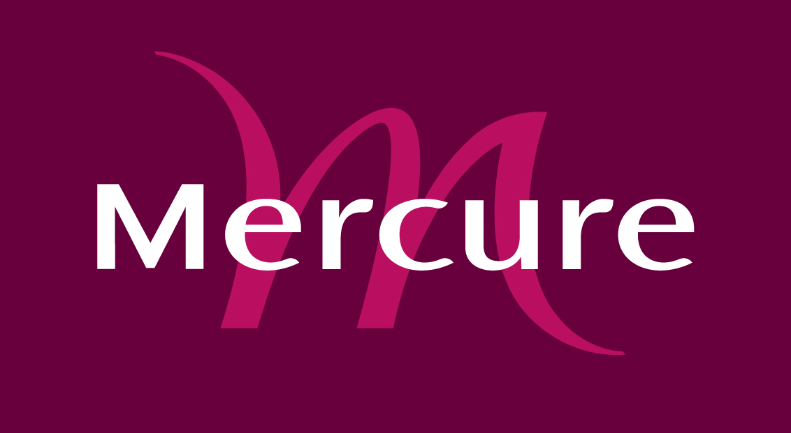

HOSTED BY


ING BELGIUM SA.
15th EUROPEAN INTER BANK TEN PIN BOWLING CHALLENGE
BRUXELLES, BELGIUM
EASTER 2015 – April 04th to 05th 2015

“Welcome to Brussels″, ″Bienvenue à Bruxelles″, ″Benvenuti a Bruxelles″, “Herzlich Willkommen in Brüssel″, ″Szívesen lát -hoz Brussels″, ″Powitanie do Brussels ″

ING Belgium Bowling Team welcomes all participants of the 15th European Inter Bank Tenpin Bowling Challenge, held at Easter weekend – Saturday 04th to Sunday 05th April 2015.

Two years have passed from the last and perfect championship in NANTES and we waited for this moment to meet you again. A special welcome to those Teams participating for the first time in this competition.

The European Inter Bank Tenpin Bowling Challenge was first held in 1987, at the initiative of Sport Association of Banque de France – CHAMALIERES. It has been held at various venues around Europe every second year since then – (see European Inter Bank Tenpin Bowling at http://www.bowlingaziendale.it/ )

The entry fee is € 300 for team.

We would appreciate your returning entries forms as soon as possible but, in any event, to reach us no later than 23th of January 2015.
Since only 28 teams can be accepted, we will apply “first come-first served allocation”.

Accommodation :
All accommodation directly by yourself to the Mercure Brussels Louise Center
We have negotiated very attractive prices for you !

Rate per Room/night including buffet breakfast & city taxes :
One person 70€
Two persons 80€

!!! For the people who wish to stay longer in our capital, we have negotiated the same price for the period from 30/03 till 06/04 (for the 6 till 12 the prices are 135/145 €).

To get this rate, you must use the “Reservation form EURO 2015” attached on this mail. This hotel has a perfect situation near the center of the city, in the “Quartier louise”.
The folder of the hotel is also attached on this mail.

Sunday night, 5th the banquet and the Victory Ceremony for all players and supporters will be held at the Mercure Brussels Louise Center.
The cost is € 70 / person

BOWLING CENTRE

The 15th European Inter Bank Tenpin Bowling Challenge will be staged at the Bowlmaster:

http://www.bowlmaster.net

PAYMENT

Total payment for entry fees and banquet tickets must be paid in same-time with your entry.
Payment are to be made by SWIFT (no cheque) with all charges paid by yourselves in favour of

Account Name: TOURNOI INTERBANQUE EUROPEEN 2015
Account no: BE40 3631 3805 2763
SWIFTBIC: BBRUBEBB

Please add Ref/Message: "euro Interbank (your Bank/Team Name)".

Remember, for the hotel reservation you must use the “Reservation form EURO 2015”.

You will find in attachment the following documents :

- euro challenge 2015 entry form.doc
- euro challenge 2015 playing rules.doc
- Reservation form EURO 2015.xlsx
- Presentation.pdf

We attach an entry form and a copy of the rules governing the competition.

If you need more information concerning this competition please contact:

stephane.batsle@ing.be - stephane@batsle.be - dominique.brosens@ing.be -

tel : (00 32) 496 41 01 47 (00 32) 475 68 86 61

